How to Belay for Climbing
Belaying your climbing partner symbolizes support and attention. It demands vigilance. Although today many climbers learn belaying in the gym, using self-locking mechanical devices such as Grigris that seem fail safe, belaying will always be vulnerable to human error.
In the 1970s, many aspirant climbers underwent a brutally primitive, though effective, belay test. The student belayer was lashed down; an instructor dropped a concrete bucket from a tower, which the hapless student had to stop, with but a rope around his waist and bare (trembling) hands. This old way of teaching certainly proved the immense forces that a fall can generate, and the necessity for diligence.
Climbing provides a great community, but as concentrations of people and conversation at any cliff increase, diligence suffers. Even in a laughing crowd, you must concentrate on your leader. Watch her, with your face upturned.
Do not be distracted, including by the climber who strolls along and asks you for beta or how your summer is going. It’s better not to talk to anyone when you are belaying. The easiest course is to be straightforward: “I can’t talk when I’m belaying, talk to you after he finishes.

BELAY DEVICES
Most climbers use mechanical friction devices, which all basically work the same. You clip the device with the lead rope threaded through it to a locking carabiner on your harness belay loop (check the manufacturer’s instructions). Double-check to see that you’ve locked the carabiner, and periodically re-check it.
The belayer feeds out and/or takes in rope through the device, be it an Air Traffic Controller (ATC), Sticht plate, Tuber, or similar device (all often colloquially called ATCs). The guide hand operates the rope on the climber side of the ATC; the brake hand holds the rope on the other side and locks down to catch any fall. The single most important tenet of belaying is never to let go with the brake hand.
A sickeningly common sight is to see someone, even an experienced climber, feeding out the rope in short tosses and opening or removing his brake hand to come back and reset. If the climber falls right then, the belayer’s brake hand is off the rope. He could hit the ground. And that’s inexcusable.
The trick to avoiding this syndrome is to keep the brake hand nearer your body and the guide hand always farther away. Letting the brake hand grasp the rope outside of the guide hand is what leads to the inclination to remove the brake hand to reset it.
BETTER BELAYING
The amount of rope the belayer pays out varies and is a matter of experience and common sense. Bottom line: catch your climber. Keep her off the deck. The second basic precept is to keep the slack to a minimum, to reduce the fall length. In some situations, for example, when a climber is seconding just above the deck, tighten up your belay.
Also, be careful not to keep the rope too tight when the leader is moving fast or traversing, in which cases a rope that’s too tight might either pull her off or even aid her, voiding her hard-earned clean ascent. Another very common error, is not to pay out enough slack for a climber to reach smoothly to clip an overhead bolt or a piece of high pro (perhaps a wired nut fiddled in at a stretch). A sticky belay can even cause a climber to fall. Watch the climber’s moves, and anticipate the clips. Pay out slack as the climber reaches down for the rope to clip a bolt or chock, not, belatedly, as she tries to pull up the rope.
Climbers on lead, for their part, save energy by clipping only as they pass a bolt at about waist height. Still, many clip when they can, such as from a good ledge, or stretching up to reach a bolt, to minimize a potential fall.
When belaying someone on toprope, keep the rope a little loose, rather than taut.

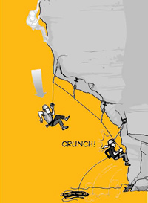
Mobility in a ground belay is useful, but there are excellent reasons to set a ground-level anchor.

LOUD AND CLEAR—BELAY COMMANDS
Communication between the belayer and climber is one of the most important—and neglected—aspects of belaying. You’ll see experienced climbers become careless with belay commands.
The signals are simple.
When you are ready to climb, ask:
“On belay?”
Wait to climb until hearing:
“Belay on,” or, “You’re on.”
Reaffirm that your belayer is ready by saying “Climbing,” and don’t climb until your belayer responds, “Climb on.”
You won’t always be able to see your partner or hear him well—if the route is long, or it traverses, or the wind is blowing hard, or you are climbing above a rushing river—so belt out the signals. And don’t climb or take someone off belay until you know you’re on or he’s off. When in doubt, wait and keep yelling. Never take someone off until you are sure.
One woman got to the top of a toproped pitch and yelled down to the belayer, who mistook her, “Got me?” for, “Off belay.” The belayer disconnected his device from the rope. She leaned back, expecting to be lowered. She plummeted 70 feet, and broke several bones—but it could have been worse. The two should have discussed how she was going to descend before she left the ground. He should have been certain of her words, and she should have waited for his OK before weighting the rope.
Develop a signaling system for situations where you cannot hear one another. When you are leading, tie in to an anchor and give three sharp tugs on the rope to signal you are off belay (while also shouting the words). Belaying, tug back three times to show understanding. When the leader is ready to belay, again give three tugs. The second should give three affirmative tugs back before unplugging the belay and climbing.
THE THREE Bs
The various belay scenarios include belaying a leader (from the ground or from stances on multi-pitch routes), belaying a follower from above (toprope), and belaying someone on a “slingshot” toprope, where the rope runs from below up through the anchor and back down to the climber.
Once a climbing team is off the ground on a multi-pitch route, the belayer must be secured to a bombproof anchor.
The leader can clip into one of the top pieces in the anchor before taking off. In the event of a fall, this directional takes substantial force off the belayer. A short fall close to the belay puts much more impact on the anchor and belayer than a long fall 100 feet up a pitch, where friction and the elasticity of the rope absorb much of the force.
On a multi-pitch route, as a leader leads up from a belay, the force on the belayer changes from a downward to an upward pull. Always set a multidirectional belay by placing at least one solid piece to protect against an upward yank. The piece keeps the belayer from getting lifted and protects the anchor from dislodging.
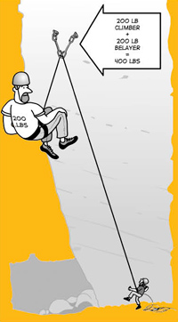
On multipitch routes, to avoid falling directly onto the anchor and belayer, the leader should place a piece of protection as soon as possible after leaving the belay. Don’t be cocky; even on easy terrain, you could pop off. If the leader falls from 10 feet above the belay, he’ll gain momentum for 20-plus feet before you catch him. Worse, such a fall, with no protection in between, could rip the anchor. A single piece of gear above the belay gives significant mechanical advantage, and the more the merrier, creating a gentler catch.
Pay close attention to the belayer’s position relative to the climber. On multi-pitch routes, belays can be hanging (no ledge), sitting or standing. Again, the belayer needs to be stationed in a direct line between the anchor and the climber, and tied tightly to the anchor, to avoid shock-loading the belay anchor or being jerked off balance. You should position yourself to absorb as much of the force of the fall as possible. When you’re belaying a second, a solid sitting or standing position can hold virtually all the force of a fall, minimizing stress on the anchor.
A hanging belay affords little opportunity for you to absorb the forces of a fall, mandating the sturdiest anchors. Again, make sure the anchor is reinforced with a piece for an upward pull. Then simply tie off tight to the anchor.

Anchors are everything. Even during a simple lower, the anchor is subjected to a force twice that of your weight.

GROUND CONTROL: SLINGSHOT AND LEAD BELAYS
Many climbers never leave the comfort of a ground belay. However, while short, bolt-protected climbs may seem relatively safe, sport climbing, ground belays and related ropework have yielded a whole new slew of accidents connected to actions done by rote. All it takes is one moment of inattention to create an accident you will regret all your life.
Whether the belayer should be anchored on a ground belay is a matter of judgment. If there is any possibility of getting pulled off a ledge, or up to hit your head on the underside of an overhang, set up a ground anchor. A climber standing 15 feet from the base of a climb, seeking shade but not thinking to tie into the tree, can be dragged through trees and thorns if her partner falls. Meanwhile, he falls 15 extra feet. In general, stand under or near the first piece.
At sport crags these days, you’ll seldom see the belayer anchored. For the most part, mobility can be useful. When the leader is beginning a pitch, the belayer can help by holding the rope out of the way of key hand and footholds and by positioning himself so the rope is available for easy clipping. A mobile belayer can also provide slack for that desperate clip by quickly stepping forward, or up onto a rock bench.
Likewise, the belayer can potentially save the leader from hitting a ledge or the ground by jumping back to take in rope.
Keep a constant eye on the leader, for his safety and your own. Beware of rockfall he may dislodge.

SOFTEN UP
Most important is that you learn the basics of good, safe belaying. Once you have those down pat, you can belay certain kinds of falls more accurately.
Start by knowing that all techniques to reduce or alleviate a fall rely on judgment. Reeling in an armload of slack can keep a leader from hitting a ledge. On steep sport routes, however, “softening” a fall is the most common technique used. The practice helps a leader to avoid a jolt. It can help avoid the broken ankles that can happen when belayers instinctively tighten up, even lean back, to sharply reduce a fall. The theory is to let the fall happen.
One such method occurs naturally: a small person on the ground is usually lifted when catching a heavier climber. Too large a differential in weight, however, can launch the belayer 15 feet, giving the leader that much more air travel; in such a case, tie down.
Two common and simple methods that also soften a fall are to stand with knees bent, so that you straighten, or to even take a light jump just as the leader falls. Think of it as a hop just as the rope comes taut.
Other factors that help are having a new, dynamic rope, as opposed to a worn, stretched-out one; and standing with bent knees; and never sitting. Some belay devices, such as an ATC, are more dynamic than others, such as a Grigri, which operates with closing cams. A fall also gets “harder” the more that rope drag, which can compromise a rope’s ability to stretch, is present in the system.
GETTING DOWN
Sport climbing and the ground belay often involve lowering the climber, another scenario that is ripe for human error.
When the climber leaves the ground he must let the belayer know whether he plans to rappel or lower. If the climber rappels, he simply ties into the anchor, tells the belayer he is off belay, sets up his rappel, and slides down. Never take someone off belay unless you’re dead sure he is off; shout for repetitions. If, as the belayer you are uncertain if your leader is to lower or rappel, keep him on belay until his curses for slack are loud and clear.
In lowering from a climb, never run the rope through nylon webbing. The slings burn through very easily.
If a climber intends to be lowered, never undo the belay, but simply wait for the signal.
After finishing the pitch, but before weighting the rope, the climber must always ask if the belayer is ready. He should ask, “Got me?” and not move until he hears, “Yes.”
Before lowering a climber, make sure he has enough rope to reach the ground. A middle mark on the rope will tell you if there’s enough slack, but many of these marks disappear with wear. Always tie a knot in the end of the rope so it cannot fly through the belay device if the rope is not long enough. Even experienced climbers have made the basic, traumatic mistake of losing a rope end through a belay device, resulting in ground falls for their partners. Watch the end of the rope every minute. If you are the climber being lowered, verbally confirm with your partner that she has knotted the end of the rope and is keeping an eye on it.
To lower a climber, the belayer feeds rope through the belay device with his brake hand. Do this slowly and steadily.

HIGH-TECH: “AUTO” BELAY DEVICES
Many, if not most, climbers today use ATCs or similar plate devices reliant on a lockoff action with your brake hand. Many also now use self-locking belay devices, such as the Petzl Grigri. Properly used, these devices are excellent. Climbers have, however, been dropped when the belayers used the devices improperly, such as by threading the rope through the wrong way. Always consult manufacturers’ instructions carefully before using any belay device.
Another concern about these devices is that they tempt belayers to take their brake hands off the rope, a habit definitely not recommended. If you see someone belaying without a brake hand on the rope, correct the person. Especially before he belays you.

Climb Safe: Belaying Part 1

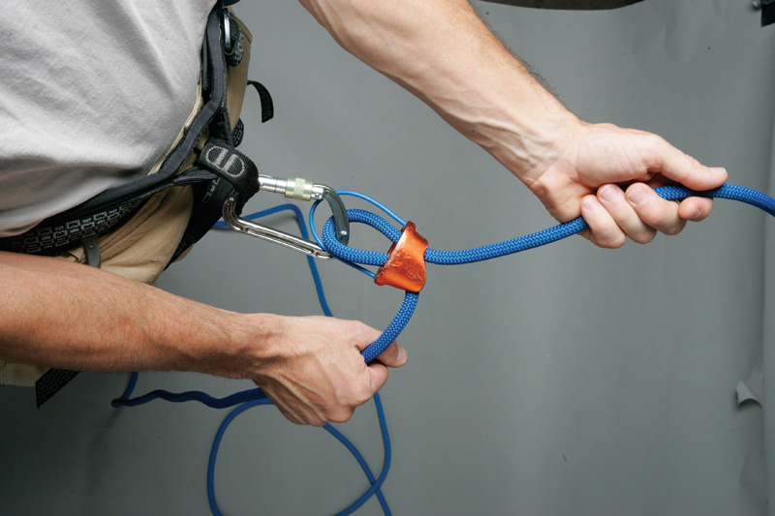
This is the right technique!

No commitment—not even the one to your SO—is as binding as that of the belay. When you hold the rope, your partner’s life is in your hands. Screw up this marriage and you give new meaning to the vow “till death do us part.” In the past, the belayer/climber partnership was indeed much like a marriage, with each partner climbing almost exclusively with the other. Today, however, we “swap” belays with almost anyone who is at hand, sometimes with mixed results.
Although commonly taught and practiced in the United States, the belay technique of holding both strands of rope parallel, in front of the belayer, “is the most dangerous way to belay with any type of plate device,” says AMGA rock guide Adam Fox.
Although many new climbers learn to belay in gyms, using auto-locking devices such as the Grigri, belaying will never be foolproof. In fact, the way many of us climb today promotes sloppy belaying. When you are in the cozy atmosphere of an indoor gym, with its bomber bolts and padded floors, and the emphasis is on getting a good burn, it’s disturbingly easy to neglect the fundamentals of belaying. When you go to the crag, a decisively less forgiving arena than the gym, your bad belay practices can exact a hard lesson.
“A lot of people assume that if the rope is going through the device, then the belay is good, when in fact it is not,” says longtime climber Kurt Aronow, who became alarmed when he noticed that about half the climbers at a local gym employed technique so poor the leader was hardly even on belay.
WHAT’S WRONG?
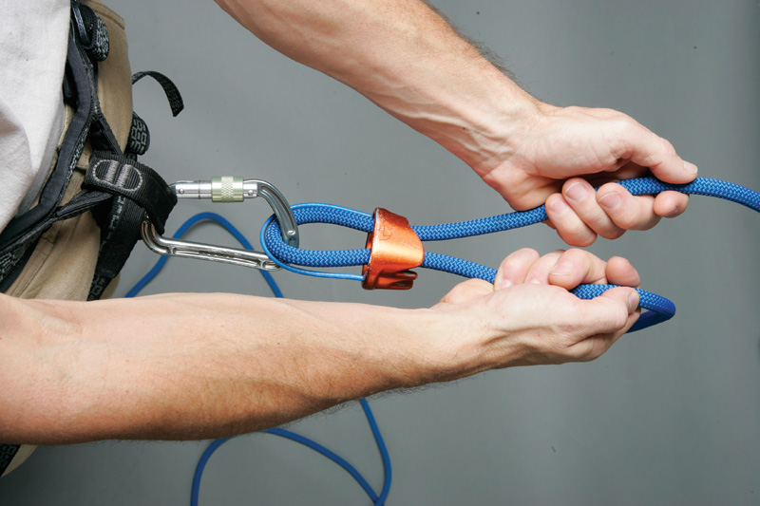
Wrong! For a standard plate-style belay device to lock, the brake side of the rope must be held at an angle. However, holding the ropes parallel (above) is a commonly taught technique despite the fact that this position cannot hold a fall!

Although commonly taught and practiced in the United States, the belay technique of holding both strands of rope parallel, in front of the belayer, “is the most dangerous way to belay with any type of plate device,” says AMGA rock guide Adam Fox. Up to 80 percent of Fox’s students, he says, come to him having learned this improper belay technique.
For a plate-style device (such as an “ATC” or “Tuber”) to lock, the braking side of the rope must be pulled back at an angle. When the rope goes straight in and straight out of the device, as it does when you hold both sides of the rope in front of you, the device may not lock.
Try this quick test to see for yourself: On the ground, rig the rope through your plate-style device, and hold both strands, parallel to each other, out in front of you. Grip the rope just as you would do if you were actually belaying.
To simulate an unexpected fall, close your eyes, and have a friend yank hard on the “leader” side of the rope.
The burning pain in your brake hand, caused by the rope whipping through the device proves the shortfall of this technique.
Much of the time you can anticipate a fall and, even when you hold both ropes parallel, can swing your brake hand to the side and properly catch the fall. But, when the leader takes a surprise fall, such as when he is climbing out of sight, you may not be able to pull the brake hand back in time. Then, the leader will either take an unnecessarily long fall, or even hit the ground.
WHAT’S RIGHT
The key to a proper belay is to keep the brake hand off to the side of the device, so the brake side of the rope angles into the device. In this position, as long as the brake hand grips firmly, the device can cinch down on the rope. To verify, try the simple belay test you took a moment ago. Positioning the brake hand off to the side makes catching unexpected falls a cinch.
This belay technique, like any, only works when the brake hand grips the rope. Unfortunately, out at the crag and in the gym you often see a belayer feeding out or taking in rope in short tosses, opening or even removing his brake hand to reset it. If the climber falls while the belayer’s hand is loose or off the rope, he probably won’t catch the fall. The single most important tenet of belaying is to never let go with the brake hand.
To avoid the temptation of loosening or releasing your grip, keep your brake hand near your body. When your brake hand drifts away, holding the rope becomes awkward and you are inclined to remove and reset your hand. Bad! Use the following steps to belay correctly.
TO REEL IN SLACK
1. Position your hands on the rope so the guide hand is on the side of the rope that goes to the climber. Hold your brake hand firmly on the braking side of the rope, and off to the side, a comfortable distance from the device.
2. Pull slack through the device with your brake hand. Keep your brake hand closed around the rope, and aim for frequent small moves rather than long pulls. Your guide hand should loosely grip its side of the rope, and assist the brake hand by simultaneously pulling in rope.
3. As you reel in slack, your brake hand will move away from your body. Reposition it by moving your guide hand and placing it on the rope outside your brake hand. (Don’t place your guide hand between the device and your brake!)
4. Grip the rope with your guide hand, and quickly slide your brake hand closer to the device.
5. Return your guide hand to the guide side of the rope.

PAY OUT SLACK
1. Position your hands on the rope so the guide hand is on the side of the rope that goes to the climber. Hold your brake hand firmly on the braking side of the rope, and off to the side, a comfortable distance (usually about a foot) from the device.

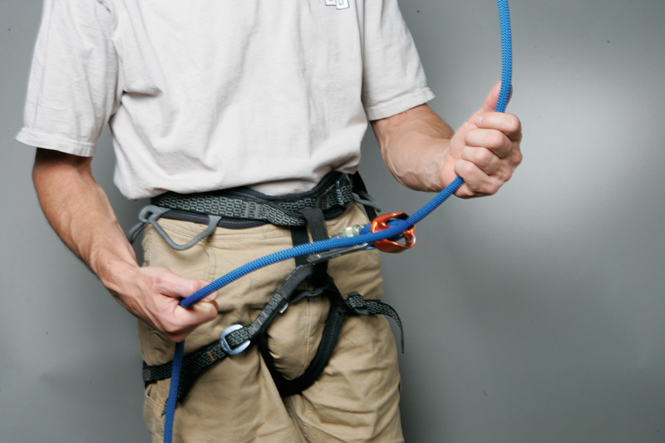

2. Use your guide hand to pull slack through your belay device, toward the climber. As you pull slack, your brake hand, which still grips the rope, will be pulled toward your belay device. When your brake hand nears the device, you’ll need to reposition it.

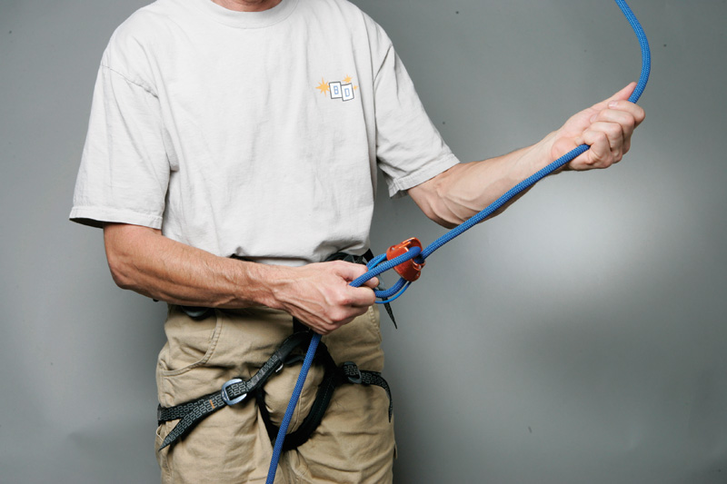

3. Remove your guide hand from the rope, and place it on the braking side of the rope, outside your brake hand and about a foot past it.

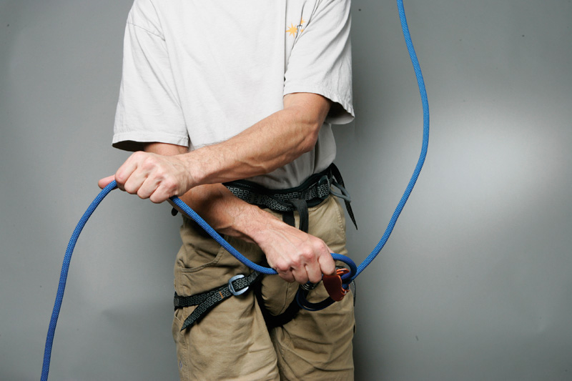
4. Slide your brake hand down the rope until it butts into your guide hand.

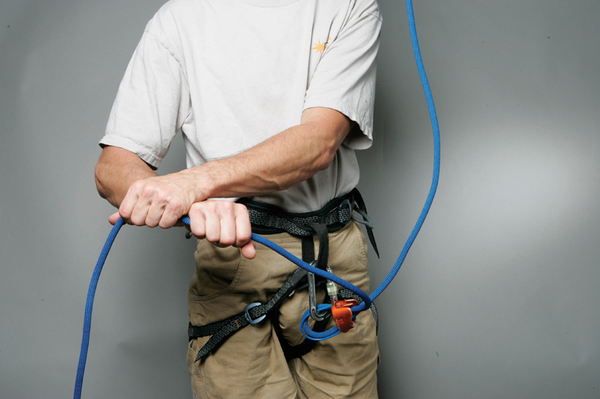

5. Return your guide hand to the guide side of the rope.

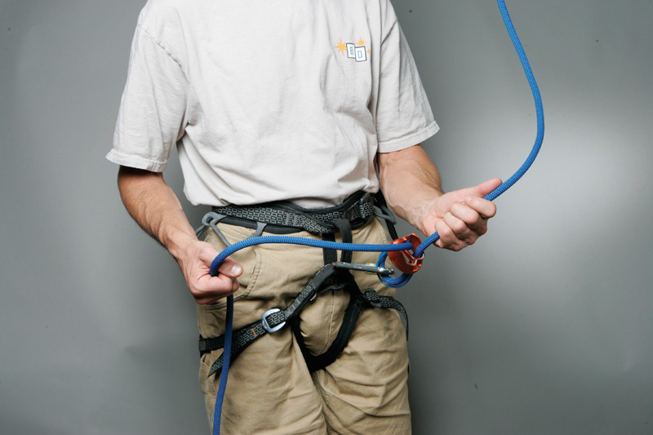
Taking in and paying out rope—automatically, and without once opening or loosening the brake hand—is awkward at first, but comes naturally with practice. Brush up on these techniques on the ground, before you belay someone.
› Although most devices work similarly, the nuances of each can differ just enough to cause you to make a mistake. Pick a device that you really like, and always use it.
› Always tie a knot in the free end of the rope, or have the belayer tie into the end. This simple step will prevent the climber from being lowered off the end of a too-short cord.
› If the belayer needs to lock off the belay, tie an overhand figure-eight knot in the brake side of the rope. If the climber weights the rope, the knot will jam into the belay device, locking it.
› Establish a set of belay commands that both belayer and climber understand.
› Keep your eyes on the climber.

Climb Safe: Belaying Part 2

In 1980 my college roommate, Mark Herndon, fell 100 feet on a two-pitch route. I was belaying from a stance at the end of the first pitch, cooling my feet, shoes off. Mark had just cruised the second-pitch crux, a near-holdless paddle up granite glass, and was nearing the end of a 50-foot runout above the route’s only lead bolt when he slipped.
Back at the belay, I figured that the serious climbing was over and was gazing stupidly at my toes when a giant loop of slack suddenly spooled down the face. I glanced up to see Mark looming larger and larger.
I froze, horrified by the prospect of witnessing—and catching—the daddy of all falls. As Mark scorched past me, I caught a strong whiff of his E.B.s burning on the rock. Panicked, I reeled in an armload of slack—just enough to catch him a few feet above a sea of knobs. Instead of splintering his ankles, or worse, Mark walked away with a serious road-rash and a backside full of quartz granules that my mother, a nurse, carefully tweezed out of his buttocks that evening.

That day I learned that dropping trou in front of your partner’s mother is a humbling procedure, but, moreover, people can—and do—fall when you least expect it. Be ready.
Last issue’s Climb Safe covered a common belay mistake: “Holding the ropes parallel.” How you hold the rope is just one aspect of the belay, however, and no more or less important than vigilance, rope management, how and where you stand, and communication.

DON’T BE A SHORT-ROPE DOPE
A year and a half ago, the 20-year climbing vet Wolfgang Schweiger was dropped 30 feet into talus when his belayer lowered him off the end of his rope. Schweiger survived, but was critically injured. In the increasingly common accident, the belayer believed the rope was long enough to lower Schweiger to the ground, when in fact it wasn’t. Never think that your belay rope is long enough for a climb, know it is.
Do this by:
1. Knowing the climb. Lowering accidents often occur on routes that the belayer or leader hasn’t done before, and one or both underestimate the pitch length.
2. Knowing the rope. Check the tags on the rope ends for the rope length. If a tag is missing, one end of the cord has probably been trimmed off, shortening the rope. Beware!
As an additional precaution, do as AMGA rock guide Adam Fox calls “closing the system” by having the belayer also tie into an end of the rope. When both ends of the rope are tied to a person, it is impossible to lower the climber off his end. Alternately, tie a knot in the free end of the rope. Knotting or tying into both ends of the rope might seem unnecessary when you are sure that your rope is plenty long, but it should be a habit.
KEEP YOUR EYE ON THE BALL
According to a recent study, you are more likely to be hit by a car when you cross a street using a crosswalk than when you jaywalk. Why? Because when you are in a crosswalk, you assume you are safe and don’t pay much attention to traffic. When you dart illegally across the street, you know you are at risk, and have your radar on full alert.
Belaying is like that. Both the leader and belayer can take for granted that the system will look out for them, and get lax. When you belay, always concentrate on your leader, watching with your face upturned. Do not be distracted, even by the climber who strolls along and asks for beta or by the dog soaking your pack. Don’t talk to anyone when you are belaying. If someone tries to strike up a conversation, say, “I can’t talk while I’m belaying, talk to you after he finishes.” Similarly, avoid asking questions of someone who is belaying or climbing. Lack of attention is a leading cause of belay accidents. All it takes is one mistake to create an accident you will always regret.
The amount of rope the belayer pays out varies and is a matter of experience and common sense. Bottom line: catch the climber. The second basic precept is to keep the slack to a minimum, to keep falls as short as possible. In some situations—for example, when a climber is seconding just above the deck—you’ll need to keep the belay tighter than you normally would.
However, be careful not to keep the rope too tight when the leader is moving fast, traversing or executing a dyno, in which cases you might either pull him off or aid him, voiding the hard-earned clean ascent. Another very common error, especially in sport climbing, is to “short rope” the leader by not paying out enough slack for the leader to clip overhead protection. A sticky belay can even cause the leader to fall. Watch the leader’s moves, and anticipate the clips. Pay out slack as the climber reaches down for it, not as he tries to pull up the rope. Often, you can feed out a couple of feet of slack simply by taking a step or two forward (or backward to quickly pull in slack).
When you belay someone on toprope, keep the rope a little loose, rather than taut, once the climber gets a few body lengths up the climb. When the climber is just leaving the ground, however, pull the rope as taut as possible to minimize the chance he’ll deck on the opening moves.
On runout routes, ones where a ground fall is possible, the belayer can consider running away from the cliff when the leader falls, taking rope out of the system and shortening the fall distance much faster than you can pull slack through a belay device. This technique causes an abrupt catch, and will increase the impact on the protection, but is better than the alternative.
GROUND SCHOOLED
Many climbers never leave the comfort of the ground to belay. While a ground belay may not involve the inherent dangers—such as anchor failure—associated with multi-pitch belays, a ground belay has dangers all its own. Whether the belayer should anchor on a ground belay is a matter of judgment. If there is any possibility of getting pulled off a ledge, dragged across the ground into obstacles, or jerked up to hit the underside of an overhang, the belayer should anchor.
At sport crags, you’ll seldom see the belayer anchored. For the most part, mobility is useful here. A mobile belayer can, as previously discussed, step forward to provide instant slack for a desperate clip, or step back to take out slack quickly. On steeper sport routes, an unanchored belayer might also “soften” a fall by jumping up the moment he feels the falling leader’s weight come onto the belay. In cases where the belayer is sizably lighter than the leader, the belayer can be launched into the air, naturally softening the fall but also possibly slamming the belayer into the wall or pinning the belay device against the first piece of pro, causing the device to jam open. In such a case, and especially when the leader greatly outweighs the belayer, tie down.
Regardless of whether the belayer is anchored, never belay sitting. Lounging around makes it more difficult to control the rope, and promotes inattentiveness. Always belay standing, with two hands on the rope, eyes on the climber.
COMMAND CENTRAL
This past summer, in Yosemite, a leader finished a 5.10d pitch, clipped the rope through the anchor and gave the thumbs up for lowering to the belayer. Unfortunately, the belayer thought the thumbs up meant “off belay.” The leader fell 100 feet to the talus breaking both legs but survived.
Communication between the belayer and climber is a critical but often botched aspect of belaying. Even experienced climbers become careless to the point where they seem to rely on telepathy.
We use many signals to communicate our intentions, but the simpler and the more common, the better. It’s especially important to use commands that can’t be misinterpreted. The following are the most universal.
When a climber is ready to climb, he asks, “Am I on belay?”
The belayer says, “Belay on.”
The climber then says, “Climbing,” and climbs after the belayer replies “Climb on.”
When the climber needs slack to make a clip or a move, he says “Slack.” When he needs the rope pulled tight, he says “Up rope.” Many climbers use “Take” when they need the rope pulled tight so they can hang, but be careful, “Take,” from a distance or in the wind can sound like its opposite command, “Slack.”
Before a climber leaves the ground he must let the belayer know whether he plans to rappel or lower. If the climber intends to rappel, he simply ties into the anchor, tells the belayer he is “off belay,” sets up his rappel, and raps down. Never take someone off belay unless you’re positive he is off; shout for repetitions until you are sure.
If a climber intends to be lowered, never unclip him from your belay device. If the climber needs slack to clean an anchor, he’ll call for “slack.” Pay out slack, but keep the climber on belay the entire time.
After the climber tops out on a pitch, but before he weights the rope to be lowered, he must always ask if the belayer is ready. The climber shouts, “Got me?” then doesn’t move until he hears, “Yes,” or “Got you.” If the belayer and climber can see one another, establish eye contact for affirmation. If multiple teams are climbing, the belayer and climber should call each other by name, to confirm that shouted commands are really meant for them. For commands that don’t require a response, the belayer should reply with “thank you” or “ok” to indicate that he heard the command.
Before lowering a climber, the belayer must make sure there’s enough rope for the climber to reach the ground. A middle mark on the rope will tell you if there’s enough slack, but most of these marks disappear with wear, and one side of the rope might be longer than the other. Again, always knot the free end of the rope or close the system by tying into both ends!
You won’t always be able to see your partner or hear him well—if the route is long, or traverses or the wind is blowing—so belt out the commands. Don’t climb or take someone off belay until you know he is off. When in doubt, wait and keep yelling.
Develop a signaling system for situations where you cannot hear one another. One common system is to have the leader tug sharply on the rope three times to signal “off belay.” The belayer then tugs back three times to show understanding and also shouts “off belay.” When the leader is ready to belay, he gives three tugs. The second then gives three affirmative tugs back before unplugging the belay and climbing.
Problem is, it can be easy to mistake a leader’s jerky movements or tugs for slack as the off-belay signal. And, if there’s rope drag it can be tough to feel the tugs in the rope. When in doubt, keep the climber on belay. It’s better to frustrate the leader by burning time sitting on belay than to drop him. Usually, after enough time has passed, all the rope has been pulled up and the belayer feels the occasional repeat groups of three sharp tugs on the rope, he’ll know what the leader wants.

